

PROVISION OF ARTIFICIAL
INTELLIGENCE TRAINING SERVICES

PROCUREMENT REFERENCE NO: AFC 10/2026

by



18 May 2026

SIMILAR EXPERIENCES AND REFERENCES

Reference Letters

TelOne

Fidelity Life Assurance

NRZCPF

Mufaro Holdings

- AI Training Services

Country | Customer |  | Contact
 | Logo | Name | Name | Phone Number
Zambia |  | SPRY Consult | Mbewe | +260955770859
Namibia |  | Northlands Medical | Dr. Matare | +264812158473
Botswana |  | Innolead Consulting | Mr O. Kgengwenyane | +26771303682
South Africa |  | Mufaro | Mr Edgar | +27719196583
Zimbabwe |  | OPC / Vice President (Dr. Mohadi’s Office) | Dr Dube | 0712322621
 | 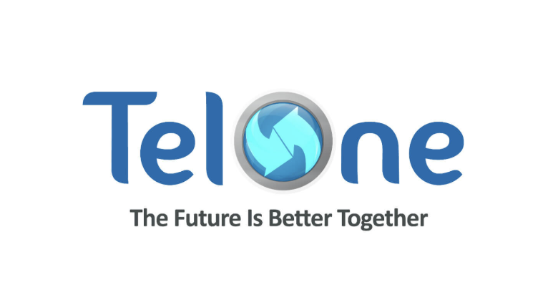 | TelOne | Mr G. Wasarira | 0773004865
 |  | POSB | Mr Kupika | 0712887944
 |  | Fidelity Life Assurance | Mr David | 0772929999
 |  | POTRAZ | Dr Dhemba | 0784166296
 |  | SECZIM | Mr Brian Gava | 0772283732
 |  | City Parking | Ms Gemu | 0772286122
 |  | NRZCPF | Mr Alfred | 0772299353
 |  | ZRP | Assistant Commissioner Philip

- Financial Services Zimbabwe

Country | Sector | Customer | Project
 |  |  | Reserve Bank Of Zimbabwe  - Digital Transformation Strategy (2024)
 |  |  | ZB Financial Holdings  - Reorganization/restructure (2020/24)  - Digital Transformation  - New Business Model and Operating Model

Zimbabwe | Financial Services |  | POSB  - Reorganization/restructure (2020/24)  - Digital Transformation  - New Business Model and Operating Model
 |  |  | Zimbabwe Stock Exchange  - Strategic Planning (2017/19)  - Digital Transformation
 |  |  | Standard Chartered Bank  - Digital Platforms  - Branchless Solutions  - Digital Transformation
 |  |  | Old Mutual  - Mergers and Acquisitions (Telecel Due Diligence and Enterprise Valuation)
 |  |  | PSMAS  - Digital Solutions
 |  |  | CIMAS  - Digital Solutions
 |  |  | Zimbabwe Association of Pension Funds  - Strategic Planning (2016)
 |  |  | Zimbabwe Stick Exchange  - Strategic Planning (2015)  - Digital Transformation

- Financial Services SADC

Country | Sector | Customer | Project
SADC | Finance |  | ABSA  - Digital Platforms  - Branchless Solutions  - Digital Transformation
 |  |  | Ubank  - Restructuring / headcount optimization  - Digital Transformation

 |  |  | FNB  - Digital Platforms  - Digital Transformation
 |  |  | NMB  - Cost optimization  - RPA  - Branchless Solutions  - Digital Transformation

SADC Secretariat, Government, Universities, Local Authorities and State Institutions

Country | Sector | Customer | Project
Government & Institutions | Public Sector |  | SADC  1. ICT Portal strategy , Design and specifications. Including regional ICT performance matrices
 |  |  | Ministry of ICT Postal and Courier Services  - National ICT Policy (2015)  - National Infrastructure Company (2026)
 |  |  | Office of President and Cabinet (via TelOne)  - Government Communications Network Design, Specifications and contract negotiations
 |  |  | City of Harare  - Reorganization and Restructure of the whole institution (2018)  - Strategic planning (2017/2021)  - Financial modelling
 |  |  | Food and Nutrition Council  - Strategic Planning (2022)
 |  |  | Zimbabwe Institute of People Management (IPMZ)  - Strategic Planning (2022)  - Restructure/ Reorganisation  - Digital Transformation
 |  |  | Great Zimbabwe University  - Strategic Planning (2021/22/23)  - Digital Transformation

 |  |  | Arupe Jesuit University  - Strategic Planning (2022/22/23)  - Restructure/ Reorganisation  - Digital Transformation

- Fixed and Mobile Telecommunications in Zimbabwe

Country | Sector | Customer | Project
Zimbabwe   | Telecoms |  | POTRAZ  - Strategic Planning (2015/16)
 |  |  | Africom  - Reorganization/restructure  - New Mobile Network (CDMA)  - Fixed Network Modernization  - Fixed-mobile Convergence Business Model
 |  |  | Powertel  - Reorganization/restructure  - New Mobile Network (CDMA)  - Fixed Network Modernization  - Fixed-mobile Convergence Business Model
 |  |  | TelOne  - Strategic Planning (2014/18, 2022)  - Reorganization/restructure (2014 & 2017)  - Fixed Network Modernization  - Fixed-mobile Convergence Business Model
 |  |  | Zimpost  - Strategic Planning (2014/18, 2022)  - Reorganization/restructure (2014 & 2017)  - TelOne MBB1 and MBBII  - Fixed Network Modernization  - Fixed-mobile Convergence Business Model
 |  |  | Dandemutande  - Technology solutions – Customer Service
 |  |  | NetOne  - Strategic Planning (2010/18, 2022/2023)  - Reorganization/restructure (2020 and 2016)  - Merger & Acquisition (Selling NetOne to MTN)  - Digital Transformation  - Network Expansion  - VAS solutions

 |  |  | Telecel  - VAS Solutions  - Mergers & Acquisitions (Old Mutual Due Diligence on Telecel

- Fixed and Mobile Telecommunications in SADC

Country | Sector | Customer | Project
Tanzania | Telecoms |   TTCL | Tanzania Telecoms Company (Fixed Line)  - Reorganization/restructure (2015/17)  - New Mobile Network (GSM)  - Fixed Network Modernization  - Fixed-mobile Convergence Business Model
Malawi | Telecoms |  | Malawi Telecoms Limited (Fixed Line)  - Reorganization/restructure (2010/13  - New Mobile Network (GSM) – via TNM  - Fixed Network Modernization  - Fixed-mobile Convergence Business Model
 | Telecoms |  | Access Communications Limited (Mobile)  - Organization/Structure (2010/13)  - New Mobile Network (GSM)  - New business operation launched from scratch  - Products and Services and channels
Swaziland | Telecoms |  | SPTC (Fixed)  - Reorganization/restructure (2008/10)  - New Mobile Network (CDMA)  - Fixed Network Modernization  - Fixed-mobile Convergence Business Model
Mozambique | Telecoms |  | mCell (Mobile)  - BSS/OSS Design and implementation  - VAS Solutions
South Sudan | Telecoms |  | Zain  - Strategic Planning (2017/18)  - Reorganization/restructure (2020 and 2016)  - Digital Transformation  - Network Expansion
Namibia | Telecoms |  | Telecom Namibia (Fixed Line)  - Reorganization/restructure (2014/16)  - New Mobile Network (GSM)  - Fixed Network Modernization  - Fixed-mobile Convergence Business Model
 |  |  | Access Communications Limited (Mobile)  - New organization/structure (2014/16)  - New Mobile Network (GSM)  - New business operation launched from scratch  - Products and Services and channels

 |  |  | PowerCom (National Infrastructure Company)  - Reorganization/restructure (2008/10)  - Merger & Acquisition (Sell to Telecom Namibia)
South Africa | Telkom SA |  | mCell (Mobile)  - BSS/OSS Design and implementation
 | Cell C |  | Cell C (Mobile) (As Employee Dr D, Magaya )  - New organization/structure (2OO2/2007)  - National Roaming Agreement with Vodacom  - New Mobile Network (GSM)  - New business operation launched from scratch  - Products and Services and channels
 | Vodacom & Vodafone  Greece |  | Vodafone (As Employee Dr D Magaya )  - GSM Network Design  - GSM Network Implementation
 | Virgin Mobile SA |  | Virgin Mobile SA (As Employee Dr D Magaya )  - New organization/structure (2OO5/2006)  - National Roaming Agreement with Cell C  - New Mobile Network (GSM)  - New business operation launched from scratch  - Products and Services and channels
Botswana | Mascom |  | Mascom (As Employee Dr D Magaya )  - GSM Network Design  - GSM Network Implementation

- Broadcasting and Media Industry

Country | Sector | Customer | Project
 | Media and |  | NBC  - Reorganization/restructure (2014/15)  - New Business Model  - Turn-around strategy  - Digitalization
 |  |  | ZiFM  - Reorganization/restructure (2015/18)  - New Business Model  - Turn-around strategy  - Digitalization
 |  |  | ZiFM  - Reorganization/restructure (2018/24)  - Digital Transformation

 | Broadcasting |  | - New Business Model  - Turn-around strategy
 |  |  | ZBC  - Reorganization/restructure (2018/24)  - Digital Transformation  - New Business Model  - Turn-around strategy
 |  |  | AMH  - Strategic Planning  - Digital Transformation  - New Business Model

- Retail Industry

Country | Sector | Customer | Project
Government & Institutions | Public Sector |  | CocaCola  1. Digital Services
 |  |  | National Foods  1. Skills Development and Training
 |  |  | Schweppes  1. Digital Services

- Health Industry

Country | Sector | Customer | Project
Government & Institutions | Health |  | NBSZ  - Strategic Planning  - Digital Transformation  - Technology Operations
 |  |  | AIBST  - Strategic Planning  - Digital Transformation  - Turn-around strategy
 |  |  | National Institute of Pathology Limited  - Reorganization/restructure (2018)  - Digital Transformation  - Process reengineering

- Industrial

Country | Sector | Customer | Project
Government Institutions | Infrastructure | 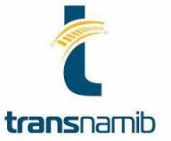 | Transnamib  - Reorganization/restructure (2016)  - Digital Transformation  - New Business Model  - Process reengineering
 |  |  | Railways Safety Regulator  - Reorganization/restructure (2018)  - Digital Transformation  - Process Reengineering
 |  |  | Harare Quarry  - Reorganization/restructure (2011/19)  - Digital Transformation  - New Business Model  - Process reengineering

